Day 37 API Posts and habit tracker

<https://pixe.la/>

<https://requests.readthedocs.io/en/latest/api/>

<https://docs.pixe.la/>

<https://www.w3schools.com/python/python_datetime.asp>



Using requests module and Pixela API 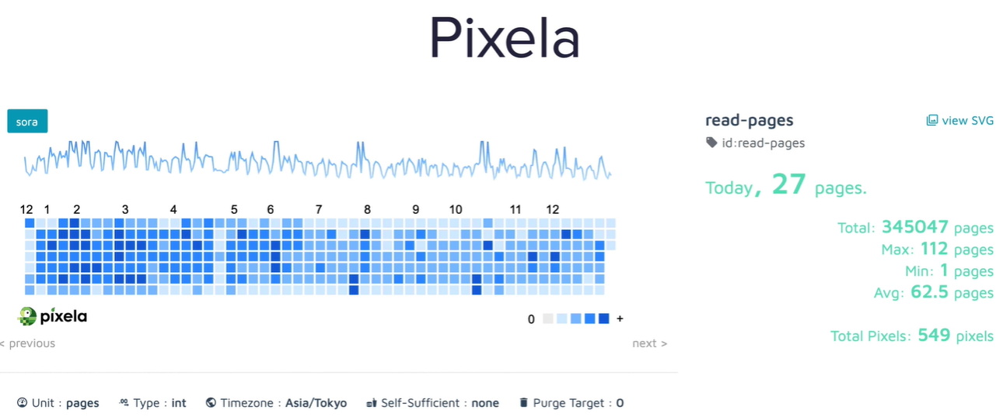

Building this :

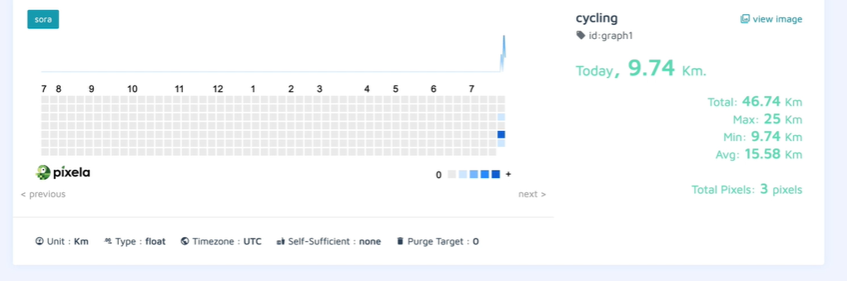

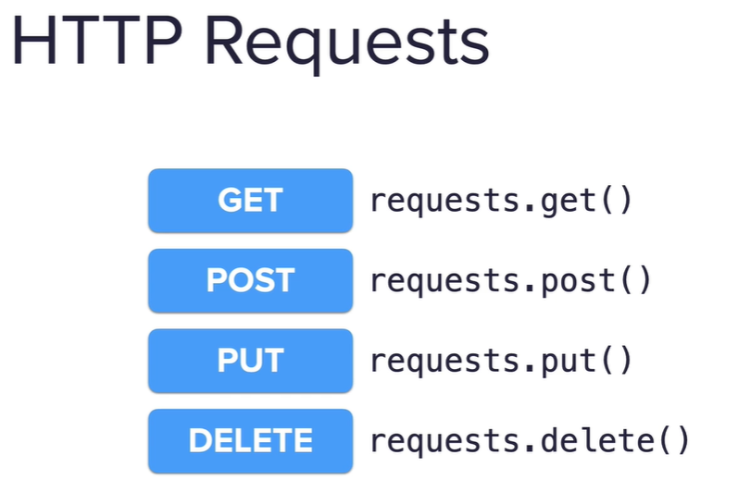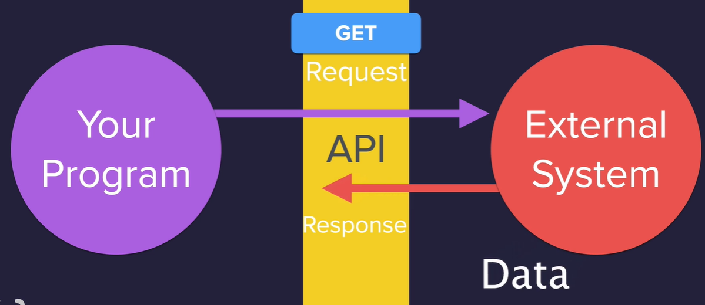

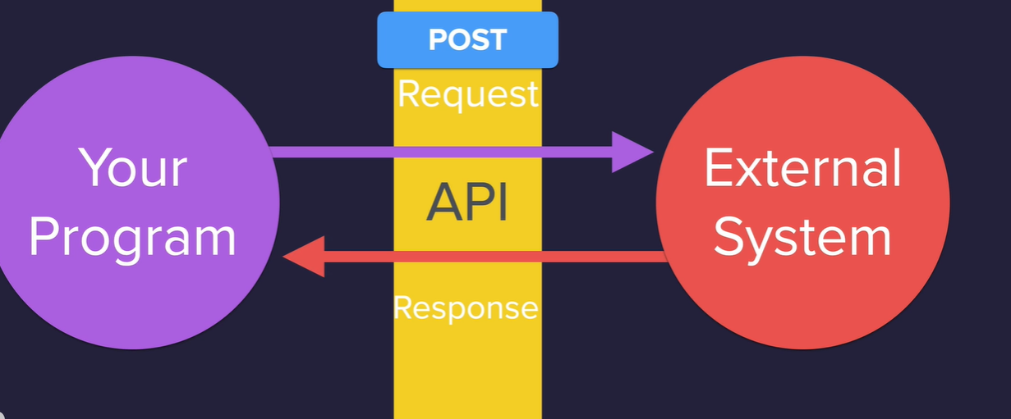

Put to update

Delete to remove

Pixela API – post habit tracking data to it to be tracked in the graph.

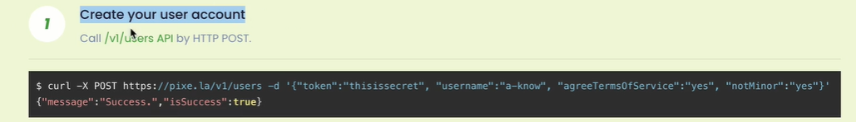

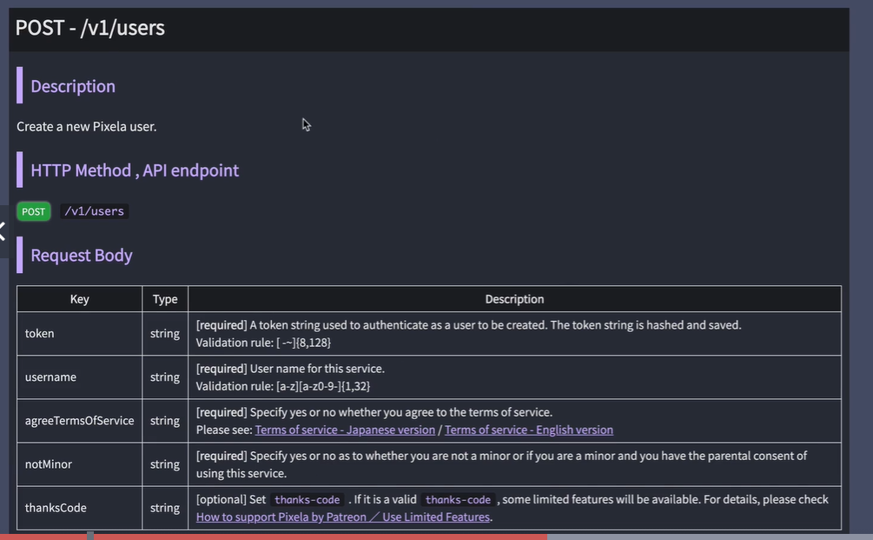

<https://pixe.la/@coloradoz99>

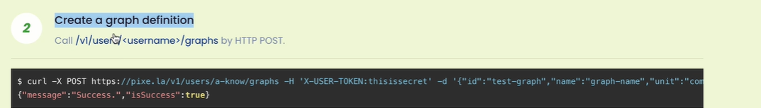

Post request to a new end point

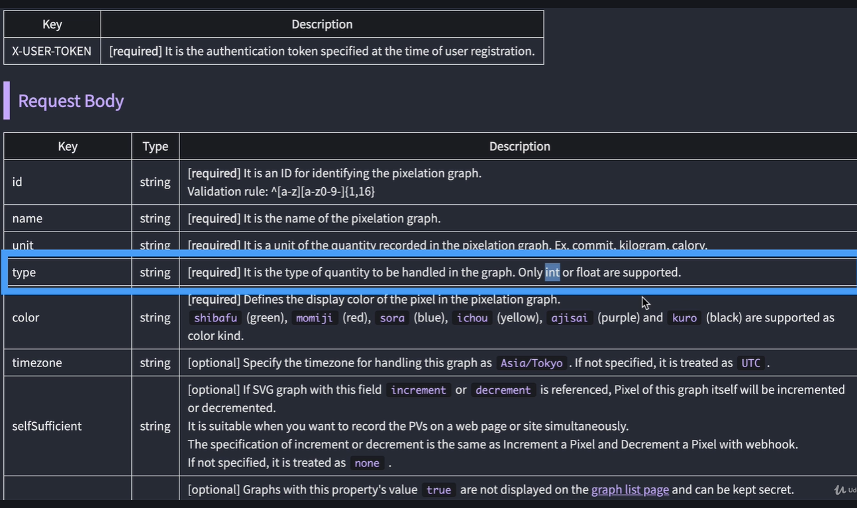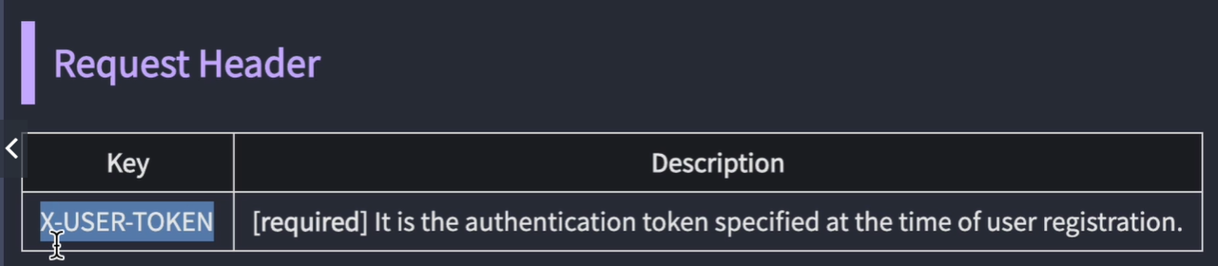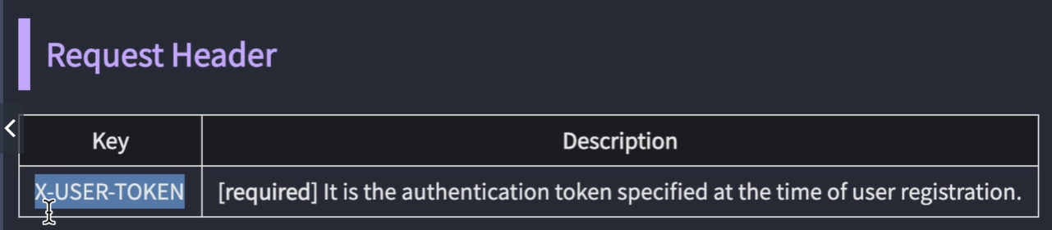

Better in request header so request sniffing doesn’t work .

# ################ create graph definition post request  
# graph_endpoint =f"{pixela_endpoint}/{USERNAME}/graphs"  
# # graph config  
# graph_config ={  
# "id": "graph1",  
# "name": "Reading Graph",  
# "unit": "Pages",  
# "type":"float",  
# "color":"ajisai"  
# }  
# headers dictionary- pass the token in the header  
headers = {  
 "X-USER-TOKEN": TOKEN  
}

<https://pixe.la/v1/users/coloradoz99/graphs/graph1.html>

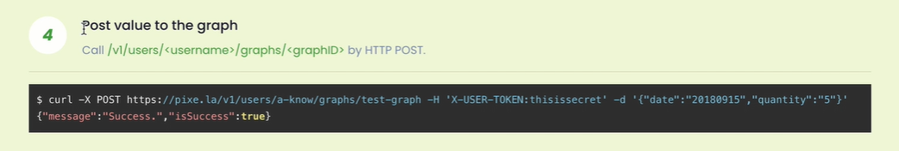

graph_endpoint =f"{pixela_endpoint}/{USERNAME}/graphs/{GRAPH}"  
reading_config={  
 "date":"20210123"**,** "quantity":"4"  
}  
response = requests.post(url=graph_endpoint**,** json=reading_config**,** headers=headers)

string of type to automate the date

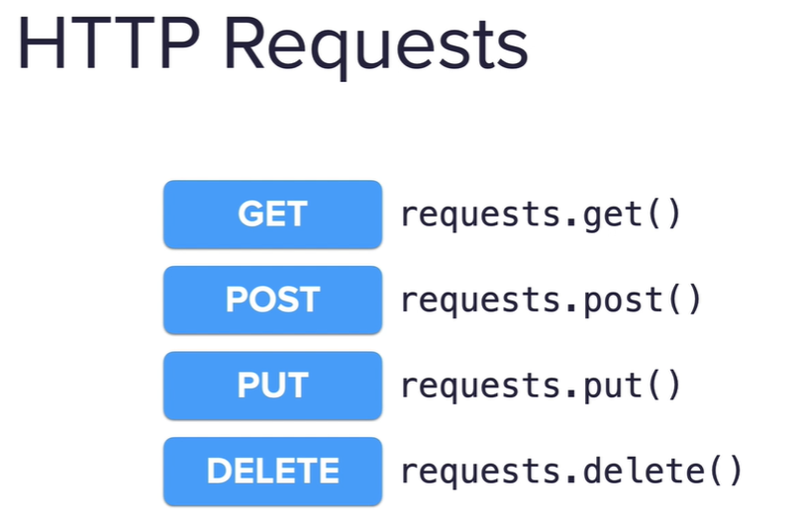

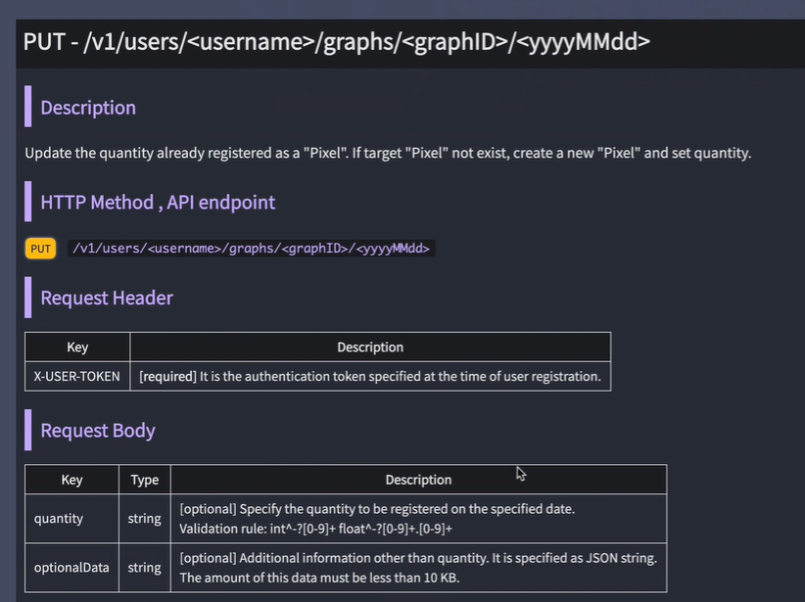

import requests  
# import datetimeclass  
from datetime import datetime  
USERNAME =""  
TOKEN =""  
GRAPH = "graph1"  
# today=datetime.now() # strftime() method  
TODAY=datetime.now().strftime("%Y%m%d")  
  
# ################### account endpoint  
pixela_endpoint ="https://pixe.la/v1/users"  
  
# headers dictionary- pass the token in the header  
headers = {  
 "X-USER-TOKEN": TOKEN  
}  
########### post  
# graph endpoint for posting data to a graph  
graph_endpoint =f"{pixela_endpoint}/{USERNAME}/graphs/{GRAPH}"  
reading_config={  
 "date":TODAY**,** "quantity":input("How many pages did you read today\n")  
}  
response = requests.post(url=graph_endpoint**,** json=reading_config**,** headers=headers)  
  
#################### update request- change the quantity to this number  
# update_endpoint= f"{pixela_endpoint}/{USERNAME}/graphs/{GRAPH}/{TODAY}"  
# update_config={  
# "quantity":"5"  
# }  
# response = requests.put(url=update_endpoint, json=update_config, headers=headers)  
  
# ################ delete request  
# delete_endpoint= f"{pixela_endpoint}/{USERNAME}/graphs/{GRAPH}/{TODAY}"  
# response =requests.delete(url=delete_endpoint, headers=headers)  
  
print(response.text)